**727721euit131_SABARI RAJ N**

**CIA 1**

**EXERCISE 1:**

**package com.Test.Cia1;**

**import org.openqa.selenium.By;**

**import org.openqa.selenium.WebDriver;**

**import org.openqa.selenium.chrome.ChromeDriver;**

**import org.openqa.selenium.firefox.FirefoxDriver;**

**import io.github.bonigarcia.wdm.WebDriverManager;**

**public class Cia1_3 {**

**public static void main( String[] args ) throws InterruptedException**

**{**

**WebDriverManager.*chromedriver*().setup();**

**WebDriver driver = new ChromeDriver();**

**driver.manage().window().maximize();**

**driver.get("https://www.amazon.in/ASUS-15-6-inch-GeForce-Windows-FA506IHRZ-HN111W/dp/B0B5DZTNZQ?ref_=Oct_DLandingS_D_6c1a28b8_61");**

**String title = driver.getTitle();**

**String etitle = "ASUS TUF Gaming A15, 15.6-inch (39.62 cms) FHD 144Hz, AMD Ryzen 5 4600H, 4GB NVIDIA GeForce GTX 1650, Gaming Laptop (8GB/512GB SSD/Windows 11/Black/2.3 Kg), FA506IHRZ-HN111W : Amazon.in: Computers & Accessories";**

**System.*out*.println(title);**

**if(title.equals(etitle)) {**

**System.*out*.println("Title is Matched");**

**}**

**else {**

**System.*out*.println("Title is Mismatched");**

**}**

**driver.findElement(By.*xpath*("//*[@id=\"add-to-cart-button\"]")).click();**

**Thread.*sleep*(5000);**

**Boolean present = driver.findElement(By.*xpath*("//*[@id=\"attach-close_sideSheet-link\"]")).isDisplayed();**

**System.*out*.println("Ttem added to cart:" + present);**

**driver.get("https://www.amazon.in/gp/cart/view.html/ref=dp_atch_dss_cart?");**

**Thread.*sleep*(5000);**

**driver.findElement(By.*xpath*("//*[@value=\"Delete\"]")).click();**

**Thread.*sleep*(2000);**

**String removeText = driver.findElement(By.*xpath*("//*[@id=\"sc-active-cart\"]/div/div[1]/div/h1")).getText();**

**String extext = "Your Amazon Cart is empty.";**

**if(removeText.equals(extext)) {**

**System.*out*.println("Product is removed");**

**}**

**driver.get("https://www.amazon.in/ASUS-15-6-inch-GeForce-Windows-FA506IHRZ-HN111W/dp/B0B5DZTNZQ?ref_=Oct_DLandingS_D_6c1a28b8_61");**

**driver.findElement(By.*xpath*("//*[@id=\"add-to-cart-button\"]")).click();**

**Thread.*sleep*(2000);**

**driver.get("https://www.amazon.in/gp/cart/view.html/ref=dp_atch_dss_cart?");**

**Thread.*sleep*(5000);**

**driver.findElement(By.*xpath*("//*[@id=\"a-autoid-0-announce\"]")).click();**

**driver.findElement(By.*xpath*("//*[@id=\"quantity_2\"]")).click();**

**System.*out*.println("Product is updated to quantity 2");**

**Thread.*sleep*(2000);**

**driver.findElement(By.*xpath*("//*[@name=\"proceedToRetailCheckout\"] "));**

**Thread.*sleep*(1000);**

**String sign = driver.getTitle();**

**System.*out*.println(sign);**

**String esign = "Amazon Sign In";**

**if(sign.equals(esign)) {**

**System.*out*.println("Checkout Failure");**

**}**

**else {**

**System.*out*.println("Checkout Success");**

**}**

**}**

**}**

**OUTPUT:**

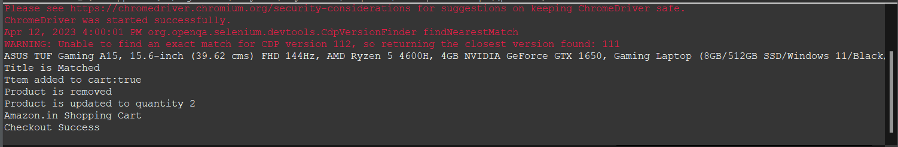

**EXERCISE 2:**

package com.Test.Cia1;

import java.util.List;

import org.openqa.selenium.By;

import org.openqa.selenium.JavascriptExecutor;

import org.openqa.selenium.Keys;

import org.openqa.selenium.WebDriver;

import org.openqa.selenium.WebElement;

import org.openqa.selenium.chrome.ChromeDriver;

import org.openqa.selenium.chrome.ChromeOptions;

import io.github.bonigarcia.wdm.WebDriverManager;

public class App {

public static void main( String[] args )

{

ChromeOptions co=new ChromeOptions();

co.addArguments("--remote-allow-origins=*");

WebDriverManager.chromedriver().setup();//setting up chrome driver

WebDriver driver=new ChromeDriver();

driver.get("https://www.amazon.in");

driver.findElement(By.xpath("//*[@id=\"twotabsearchtextbox\"]")).sendKeys("Mobiles");

driver.findElement(By.xpath("//*[@id=\"twotabsearchtextbox\"]")).sendKeys(Keys.ENTER);

String a=driver.getTitle();

if(a.equals("Amazon.in : Mobiles")) {

System.out.print("Title is Matched\n");

}

else {

System.out.print("Title is Mismatched");

}

List<WebElement> li=driver.findElements(By.className("s-line-clamp-2"));

for(int i=0;i<5;i++) {

System.out.println(li.get(i).getText());

}

driver.findElement(By.xpath("//*[@id=\"p_36/1318505031\"]/span/a/span")).click();

try {

Thread.sleep(5000);

} catch (InterruptedException e) {

// TODO Auto-generated catch block

e.printStackTrace();

}

WebElement b=driver.findElement(By.xpath("//*[@id=\"search\"]/div[1]/div[1]/div/span[1]/div[1]/div[2]/div/div/div/div/div/div/div/div[2]/div/div/div[3]/div[1]/div/div[1]/div[2]/a/span[1]/span[2]/span[2]"));

//System.out.print("Price 5,000-10,000 :"+b.getText());

driver.findElement(By.xpath("//*[@id=\"p_89/Samsung\"]/span/a/div/label/i")).click();

try {

Thread.sleep(5000);

} catch (InterruptedException e) {

// TODO Auto-generated catch block

e.printStackTrace();

}

WebElement c=driver.findElement(By.xpath("//*[@id=\"search\"]/div[1]/div[1]/div/span[1]/div[1]/div[2]/div/div/div/div/div/div[2]/div/div/div[1]/h2/a/span"));

System.out.print("Price 5,000-10,000 & Samsung: "+ c.getText());

}

}

**OUTPUT :**

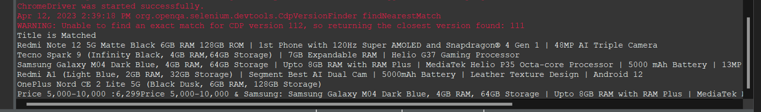

**EXERCISE 3:**

**package com.Test.Cia1;**

**import org.openqa.selenium.By;**

**import org.openqa.selenium.WebDriver;**

**import org.openqa.selenium.WebElement;**

**import org.openqa.selenium.chrome.ChromeDriver;**

**import org.openqa.selenium.chrome.ChromeOptions;**

**import io.github.bonigarcia.wdm.WebDriverManager;**

**public class Cia1_3 {**

**public static void main(String[] args) {**

**ChromeOptions co=new ChromeOptions();**

**co.addArguments ("--remote-allow-origins=*");**

**WebDriverManager.*chromedriver*().setup ();**

**WebDriver driver=new ChromeDriver(co);**

**driver.get ("https://www.amazon.in/");**

**driver.manage().window().maximize() ;**

**String currentTitle=driver.getTitle();**

**System.*out*.println(currentTitle);**

**String expectedTitle="Online Shopping site in India: Shop Online for Mobiles, Books, Watches, Shoes and More - Amazon.in";**

**if(currentTitle.equals(expectedTitle)) {**

**System.*out*.println("Title Matched");**

**}**

**else {**

**System.*out*.println("Title not Matched");**

**}**

**driver.findElement(By.*xpath*("//*[@id=\"nav-link-accountList\"]")).click();**

**WebElement txtBoxl=driver.findElement(By.*xpath*("//*[@id=\"ap_email\"]"));**

**txtBoxl.sendKeys("8688797149");**

**driver.findElement(By.*xpath*("//*[@id=\"continue\"]")).click();**

**WebElement txtBox2=driver.findElement(By.*xpath*("//*[@id=\"ap_password\"]"));**

**txtBox2.sendKeys("C0llin_H00v3r");**

**driver.findElement(By.*xpath*("//*[@id=\"signInSubmit\"]")).click();**

**System.*out*.print("Sign In Success\n");**

**driver.findElement(By.*xpath*("//*[@id=\"nav-link-accountList\"]")).click();**

**if(driver.getTitle().equals("Your Account")){**

**System.*out*.println("Your Order Page Is Displayed");**

**}**

**driver.findElement(By.*xpath*("//*[@id=\"a-page\"]/div[2]/div/div[2]/div[1]/a/div/div")).click();**

**System.*out*.println("User can Track the Package");**

**driver.findElement(By.*xpath*("//*[@id=\"a-autoid-2-announce\"]")).click();**

**//*[@id="primaryStatus"]/span**

**driver.findElement(By.*xpath*("//*[@id=\"ordersInPackage-container\"]/div/div/a[1]")).click();**

**System.*out*.println("User can view the Order Details");**

**}**

**}**

**OUTPUT :**

